Community Action Partnership for Dutchess County, Inc.
77 Cannon Street, Poughkeepsie, NY 12601
Tel 845-452-5104
www.dutchesscap.org
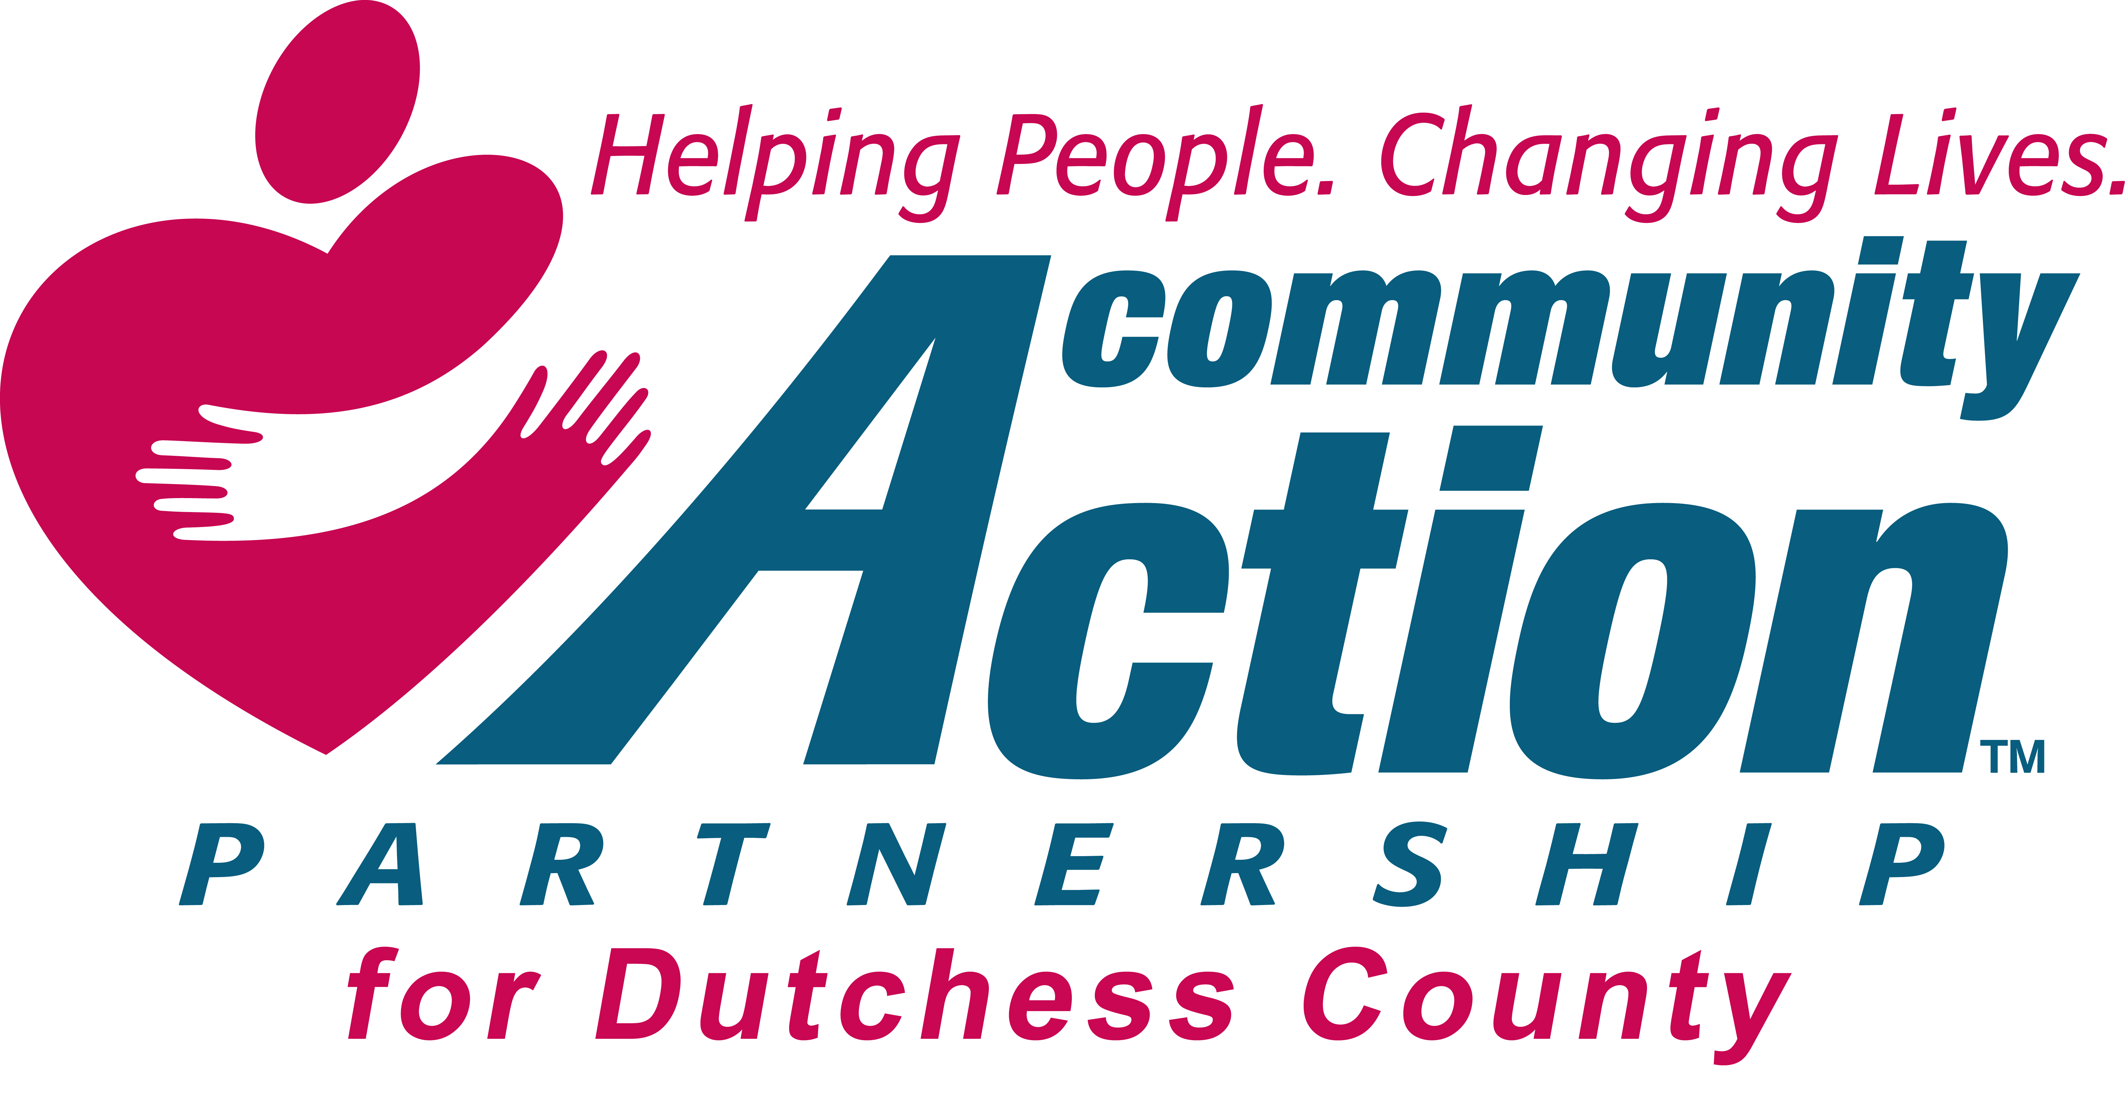

2016 Annual Report
  - CSBG FY 2016
Engaging Communities, Empowering Individuals
Contents
Welcome from our President and CEO 1

Mission, Vision, and Values 2

The Board and Executive Team 3

Focus Areas, Progams and Services 4

Snapshot of this Year’s Achievements 5

CAP for DC’s Outcomes 6

Financial Report 7

Welcome

Strategic Highlights
2016 has been a very busy year for Community Action Partnership for Dutchess County (CAP DC). Throughout the year, the agency has been completing the process of changing the incorporation name. Filings have been submitted, vendors have been notified and agency brochures and other materials have been updated.
In the spring, CAP DC began conducting a Community Needs Assessment. Consumer and stakeholder surveys were completed and the results were tabulated. The resulting Community Needs Assessment was approved by the Board of Directors at the March 2016 meeting. The first draft of the agency’s Strategic Plan has been completed. The final version will be approved at the December Board meeting.

Financial Highlights
CAP DC has continued to streamline its expenses through sound fiscal management. The Agency has reinforced its unrestricted revenues by establishing a framework for successful fundraising. The Agency’s subsidiary company, North East Home Improvement, LLC (NEHI), continues to optimize its ability to generate unrestricted income, adding additional support for the programs of the organization.
CAP DC continues to present “finding-free” audits. Our most recent independent audit (2015) did not identify any deficiencies in internal controls that would be considered a material weakness. The audit firm also did not provide any recommendations to policies or procedures. CAP DC continues to show progress in reduction of debt and improvement in overall financial health.

Operating Highlights
Community Action is committed in providing programs and services in a strength based approach, empowering individuals and families. The Family Development Credential instruction has been supported by the Community Action network for over 20 years. In the last 10 years, there has been increasing difficulty in finding qualified instructors and classes provided in locations convenient for staff to attend. Community Action Partnership Dutchess County is happy to report the agency’s Case Management Supervisor attended and completed the requirements for Family Development Credential Instructor.

Looking Ahead
If you change or add headings in this document, you can update the table of contents in a snap. To see new headings, click anywhere in the table of contents and then click Update Table.
Joseph Olah Elizabeth Carlton Spira
President CEO

Mission, Vision, and Values
Mission
The Mission of Community Action Partnership for Dutchess County is to partner with individuals and families to eliminate poverty and identify the resources and opportunities available to them to enhance their self-reliance.

Values
- To inspire the belief that positive change is possible
- To provide all services and activities with dignity and respect through a strength based approach
- To empower low-income individuals seeking greater economic self-reliance
- To be aware of and responsive to the needs of the community
- To be economically sustainable, fiscally sound and mission driven
- To maximize our effectiveness through internal and external collaboration

Vision Statement
Community Action Partnership for Dutchess County will lead the community by being the “go to” place for issues affecting low-income residents. The organization will serve as a valued community resource by providing high quality services, maintaining a knowledgeable and committed staff, and demonstrating strong and responsible leadership.

Board of Directors and Executive Team

Board of Directors
EXECUTIVE COMMITTEE
Joseph Olah, President
Charlene Smart, Vice President
Peter Idema III, Treasurer
David Scott, Secretary
MEMBERS
Everett Patterson
Eleanor Pitcher
Charlene Smart
Nathaniel Almeida
Ali Muhammad

Executive management Team
Elizabeth Carlton Spira, CEO, NCRT
Teresa Paino, CFO
Corrine Campbell, HR Director
Linda Eddy, EITC Program Director
Robin Blue-Brown, Dress for Success DC Program Director
Randy Magee, Weatherization Director
Patricia Lamoree, Weatherization Outreach/Data Management Director
JoAnn Hickman, Retired Senior Volunteer Program Director
Samantha Riley, Case Management Supervisor

STAFF
Patrick Black, Weatherization Auditor
Mildred Fleet, Client Advocate
Joseph Fletcher, Weatherization Senior Auditor
Beverly Howell, Weatherization Data Entry Clerk
Anthony Irizarry, Weatherization Crew Member
Janice Jallade, Client Advocate Assistant
Cardenal Johnson, RSVP Senior Transportation Driver
Ann Kiely, Senior Accounts Receivable
Nancy Lupi, Client Advocate
Yvonne Maloney, Client Advocate
Melissa Piscitello, Client Advocate – NedCorps
Mariella Ribbeck, Client Advocate – NedCorps
Carmen Rodriguez, Client Advocate
Elizabeth Ann Santos, Cash Receipts
Annette Spada, Senior Accounts Payable/Payroll
Charlinda Williams-McCallop, Administrative Assistant
Robert Wright II, Weatherization Crew Member

Programs and services
- Employment Assistance

Community Action Partnership helps families achieve self-sufficiency through total "wrap around services". We help individuals enter the workforce by assisting in resume writing, employment searches and practice interview skills. CAPDC employment resources include:

Dress for Success Dutchess County. Dress for Success Dutchess County provides interview and employment appropriate clothing to disadvantaged women. Our mission is to help women acquire jobs, retain new position and succeed in mainstream work place. Clients in this program are able to:
- Work on job searches at our Career Center
- Make a lasting first impression and stand out from the crowd
- Support each other at the monthly meetings of the Professional Women’s Group
- Volunteer as a personal shopper or assist newly hired women succeed in the work place by becoming a mentor in the Professional Women’s Group.

Career Center. Our Career Centers take women’s job readiness “beyond the suit” to help raise their chances of success in a competitive job market. Our Career Centers promote confidence and professionalism by pairing our clients with Career Advocates who work one-on-one with them. Together they create superior résumés and cover letters, conduct mock interviews, and facilitate access to our professional skills training course.
Going Places Network. Many Dress for Success clients have been negatively affected by today’s job market and face circumstantial challenges in finding a new position. The Going Places Network by Walmart offers a 7-week safety net of support to women. Clients meet for two hours each week, attend a workshop series on relevant job search topics, network with fellow participants, and receive additional one-on-one job search support in the Career Center.

Professional Women’s Group (Launch 2016). Along with the success of landing a new job, newly employed women often encounter an unfamiliar set of employment obstacles. From understanding corporate culture to managing personal finances, career novices are often left to navigate the unwritten rules of the workplace with little or no support. The Professional Women’s Group (PWG) bolsters the careers of successfully employed Dress for Success women by providing them with a network of support, practical information, and inspiration to remain employed so they can truly thrive.

Suited to Succeed. Suited to Succeed evolved out of a need to assist men with work appropriate clothing. Modeled after the DFS program, men’s clothing is available free of charge. Case management with CAP Client Advocates support the ongoing job search, resume writing, and interview skill development.

- Energy Conservation

Emergency Heating Program. Community Action Partnership is Dutchess County’s provider of emergency heating. There are three components to the emergency heating program:
- HEAP (Home Energy Assistance Program) - HEAP eligible households may receive a benefit, paid directly to their heating vendor
- HERR (Heating Equipment Repair and Replacement) - In the event that the HEAP eligible household’s furnace is in need of repair or replacement, the HERR program will address that need.
- ECIP (Energy Crisis Intervention program) – this program provides households who are without heating fuel on the evenings or weekends to obtain 10-20 gallons of heating fuel. The goal is to keep the family safe and warm until they are able to apply for HEAP.

Weatherization Assistance Program. Our Weatherization program helps home owners and tenants living in single family and multi-unit housing to obtain energy conservation measures that assist with the reduction in the overall energy burden and carbon footprint.

- Family Supports, Health and Wellness

Food Pantries. Dutchess County Community Action Partnership has food pantries in: Beacon, Dover Plains, Red Hook and Poughkeepsie. Families may receive a food package every 30 days. Each package consists of three days, three meals per day, for every individual in the household. There is no cost to the family. The composition of the package follows the Regional Food Bank’s requisites for nutritionally balanced meals.

Health Insurance. CAP Client Advocates will help families obtain health insurance. Uninsured or underinsured families are connected with health care providers who will schedule an appointment and meet with them at the CAP location.

Prescription Assistance. Community Action Partnership receives funds from different funder's to help individuals/families get the prescriptions they need. Exclusive the Eastern Dutchess County, the Foundation for Community Health provides funding for prescriptions and prescriptions co-pays, for uninsured or underinsured.

Financial Assistance. Financial assistance is available for emergency needs to include rent, utilities, and medical needs. Based on the available resources and each resources eligibility resources, the amount and use may be specific, such as:
- Miles of Hope Gap Care Fund – serving individuals undergoing treatment for breast cancer.
- Premier Cares – serving individuals undergoing treatment for urological and gastrological disease.
- Mastroianni Fund – may be used to purchase prescriptions or transportation to medical care (age and residency restrictions).

This just a sampling of resources available at CAPDC to assist low income families meet their basic needs. There are two other programs that offer assistance to our community.

- Earned Income Tax Credit (EITC)

The CASH coalition was established over 10 years ago when community leaders, human service providers, and financial institutions came together to develop a plan to ensure low to moderate income households were provided free, accessible, and accurate income tax return preparation.
Due to complicate tax laws, many low income families and seniors who are due refunds and credits, fail to file or file incorrect returns. Providing free reliable tax preparation assistance ensure families that are due refunds and important tax credits receive their entire refund without a loss due to tax preparation fees.

CAPDC staff takes a leadership role in the organizing the coalition’s efforts. Securing tax sites, recruiting volunteers for key roles such as tax preparers, (over 100 just in Dutchess County), supporting the extensive training of all program volunteers, securing community support and resources such as computers, printers and supplies required to operate tax preparation sites in Dutchess County.

- Retired & Senior Volunteer Program (RSVP) of Dutchess County

RSVP will assist people, 55 years of age or older, with community volunteer opportunities. The goal is to connect volunteers with an opportunity that matches their interests, providing a rewarding and necessary service for the community at area non-for-profit organizations. With volunteers organized through the RSVP program, CAP provides home delivery of hot meals to homebound seniors in Beacon, NY and transportation for Beacon seniors to the grocery store and/or community center. Additional RSVP volunteer activities include: providing transportation to the elderly for shopping and medical visits, preparing income tax returns, transporting and advocating for our veterans or working in a thrift shop.

Financial Report

Data as of September 30, 2016

Data as of September 30, 2016

Contact Information

Elizabeth Carlton Spira  CEO |  | Teresa paino  CFO |  |  | Corrine campbell  HR Director
Tel 845-452-5104 x-103  Fax 845-625-1510  espira@dutchesscap.org |  |  | Tel 845-452-5104 x-131  Fax 800-882-9625  tpaino@dutchesscap.org |  |  | Tel [Telephone]  Fax [Fax]  [Email Address]

Company Information
Community Action Partnership for Dutchess County, Inc.
77 Cannon Street, Poughkeepsie, NY 12601
Tel 845-452-5104
Fax 845-625-1510
www.dutchesscap.org

