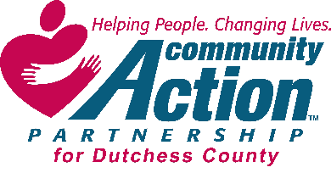
Community Action Partnership for Dutchess County, Inc.
Board of Directors Meeting
May 20, 2021

Location: Online Meeting
CEO: Elizabeth C. Spira
CFO: Teresa Paino
Attendees: Charlene Smart, Peter Idema, Joshua Stratton, John Penney, Kathleen Vacca
Excused: Dr. David Scott and Paul Daubman Sr.
Absent: None
Quorum Present: Yes
Guest: David Gabel, CPA, Engagement Director EFPR Group
Agency Staff: Elizabeth C. Spira, Teresa Paino and Jill Harlow (Administration Assistant)

Meeting called to order: Charlene Smart, the President, called the meeting to order at 3:34 pm.

Roll Call: Jill Harlow conducted the roll call.

April Minutes: The April minutes were distributed by e-mail prior to meeting. Kathleen Vacca made the motion to accept the April minutes. Peter Idema seconded the motion. All were in favor and the motion carried.

CEO Financial Report: Teresa Paino

Finance Committee Report
In Attendance: Pete Idema, Charlene Smart, Josh Stratton, Liz Spira and Teresa Paino
May 11, 2021
Funding Reductions/Increases/Impact

- Increase of $184,900 in Weatherization funding. Weatherization budget amount is $878,049.
- Increase in funding of $3,365 – CSBG grant – October 1, 2020 to September 30, 2021. CSBG budget amount is $465,532.
- New $50,000 Rental Assistance grant for outreach and application assistance (May 1, 2021-December 31, 2021). Grant has the potential for a renewal of one year (2022).
Regular Business

- Reviewed drafts of CAPDC’s 990, 990T, CHAR 500 and CT-13 tax returns. Submission due date of May 17, 2021.
- Presented final tax returns to Charlene Smart for signature.
- Continued purchases of personal protective equipment (masks, gloves, cleaning products and sanitizers).
- Prepared and assisted in submission of Rent Assistance grant to Dutchess County.
- Prepared budget adjustments for HEAP, ECIP and HER grants.
- Filed unaudited reports for Weatherization and CSBG.
- Renewed Cyber insurance policy.
- Sent RSVP Volunteer insurance policy to agent to review and find alternatives.
- Updated Vendor Responsibility Questionnaire.
- Continued work on Business Continuity Plan.
- Scheduled review of IT issues with vendor.
- Continued review of NEHI costs.
- Request vote to amend Fiscal Policy to revise Retention Policy.
Add:
  - HERR files must be retained for a period of 10 years.
- Motion to accept the Finance Report: Peter Idema made the motion to accept the Finance Report. Kathy Vacca seconded the motion. All were in favor and the motion passed.

- Motion to amend Fiscal Policy to revise Retention Policy: Peter Idema spoke towards this amendment. Once one of the policies and/or procedures is not in compliance with contract requirements, the fiscal policy will be updated with Board vote required. Pete Idema proposed that any changes that must be made to CAPDC’s Fiscal Policy with the BOD notified after the fact.
Peter Idema made the motion to amend the Fiscal Policy to revise CAPDC’s Retention Policy. John Penney seconded the motion. All were in favor and the motion carried.

CEO Report
DOS OCS – Department of State, Office of Community Service
- CSBG Contract analyst, Jessica Garneau conducted a virtual site visit on
  - Reviewed client files for CARES funding and SIS and Career Center
  - Reviewed 2nd quarter Periodic Program Report, PPR.
  - Board files update for members’ terms and designation
- 2nd Qtr. PPR review
  - Discussion items for over or under performance to be prepared for June BOD meeting.

PROGRAM updates

Dress for Success
- Suiting’s May: 23
Interview - 20
Employment - 3
- Career Center Appointments April: 8
- Programs: Spring SIS Boot Camp (4/7-5/19) 4 participants completed program on 5/19, 1 delayed
for medical reasons.

Family Resource Program

- Self-Sufficiency matrix – implementing a tool to measure clients’ progress towards self-sufficiency.
- Recognizing increased participation in the Prescription Assistance Program, funded by Foundation for Community Health, due to implementing a reimbursement component for prescriptions, co-pays, and Part D premiums.
- Anticipate receiving fresh produce for the area farms and will establish a system for distribution.
- Summer meals – Beacon and Red Hook school districts can apply for the funding to continue lunches through the summer. Restrictions eliminated due to COVID.

Data & Quality Improvement

- VERY close to having the web-based client portal operation. Links are in place and function is being tested.

RSVP –
- Director, assistant, and advisory council are making calls to the volunteers who have been inactive this past year.
- The program is beginning to implement mailing birthday cards to the volunteers.
- DC OFA is considering opening the Friendship Centers. RSVP/CAP will be looking for a volunteer to provide transportation to and from the Center for the congregate meal, Monday through Friday.

EITC
- Projection, 1/3 as many tax returns prepared for 2020. Expect to have solid numbers for the June BOD meeting.
- Additional information from IRS regarding the Child Tax Credit and filing requirements.

DC Vaccine Outreach Coalition
COVID Vaccine Outreach Activities
- Lots of Pop-Up Sites with Walk-In Appointment
  - Sun River Health
    - Saturday, May 22 - 9:00am – 2:00
      - Family Partnership Ctr
  - New Hope Manor
    - New Hope Community Center in the City of Poughkeepsie can be used as a pop-up clinic from 2 p.m-8 pm on Thursdays May 27 and June 24
  - Mexican Consult Visit
    - March 25th & June 27th
- Tabling opportunities continue and are increasing.
  - Catholic Charities Event – Last Wed
  - Wappingers Falls Event – Sat
  - Juneteenth Events in the works
- National Community Action Partnership has created media material to promote vaccinations. The CAP website is updated as materials become available.

- Other – looking for volunteers to work in the Suited to Succeed program.

HEAP/Fuel Depots
- HEAP - HEAP extend to August 31st.
- Fuel Depot – Depots are still open but seldom used.
- OTDA ERAP – Outreach and application assistance expected to begin the end of May.

WEATHERIZATION
- 2021 Weatherization: Contract period began 4/1/202, thru 3/31/22.
- Significant increase to the Dutchess County allocation, new budget prepared and submitted Tuesday.
- New allocation production is 87 units, $7,450 cost per unit (CPU) and includes over $87,000 allocated for health and safety measures
- 3 multi-unit housing projects being considered

NEHI – Fee for Service Entity

- Continuing to provide the capacity to leverage funds for energy conservation measures.
- HERR – 1 furnace still in process
- Emergency Cooling Program – ECP, provide AC units for HEAP eligible households with a medical condition requiring cooling, must have Dr.’s note.
- Empower – 12 active jobs. These applicants will receive Weatherization applications to provided combined work and expand the measures provided.

Human Resource
- Continuing to prepare updates for the Employee Handbook/Personnel Policies, anticipate having the changes ready for Board review and approval at the June BOD meeting.
- Recommendation from DOS, TRACS/ACROS, regarding political activity.
- New hire, PT in the Poughkeepsie office, began on Monday.

Motion to accept CEO Report. Peter Idema made the motion to accept the CEO Report. Charlene Smart seconded the motion. All were in favor and the motion carried.

Charlene Smart, President, stated that the CEO surveys went out to all board members. She is still waiting on a few to be mailed to her.

John Penney has left the meeting at 3:52 PM

Guest Speaker: David Gabel, CPA, Engagement Director EFPR Group joined the meeting at 4:00 PM.

- See below Power Point presentation.

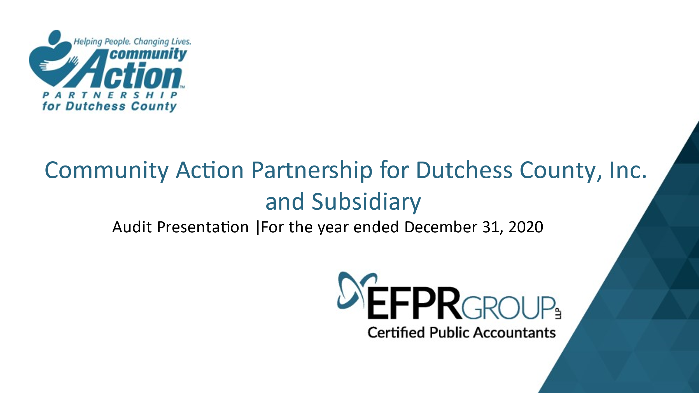

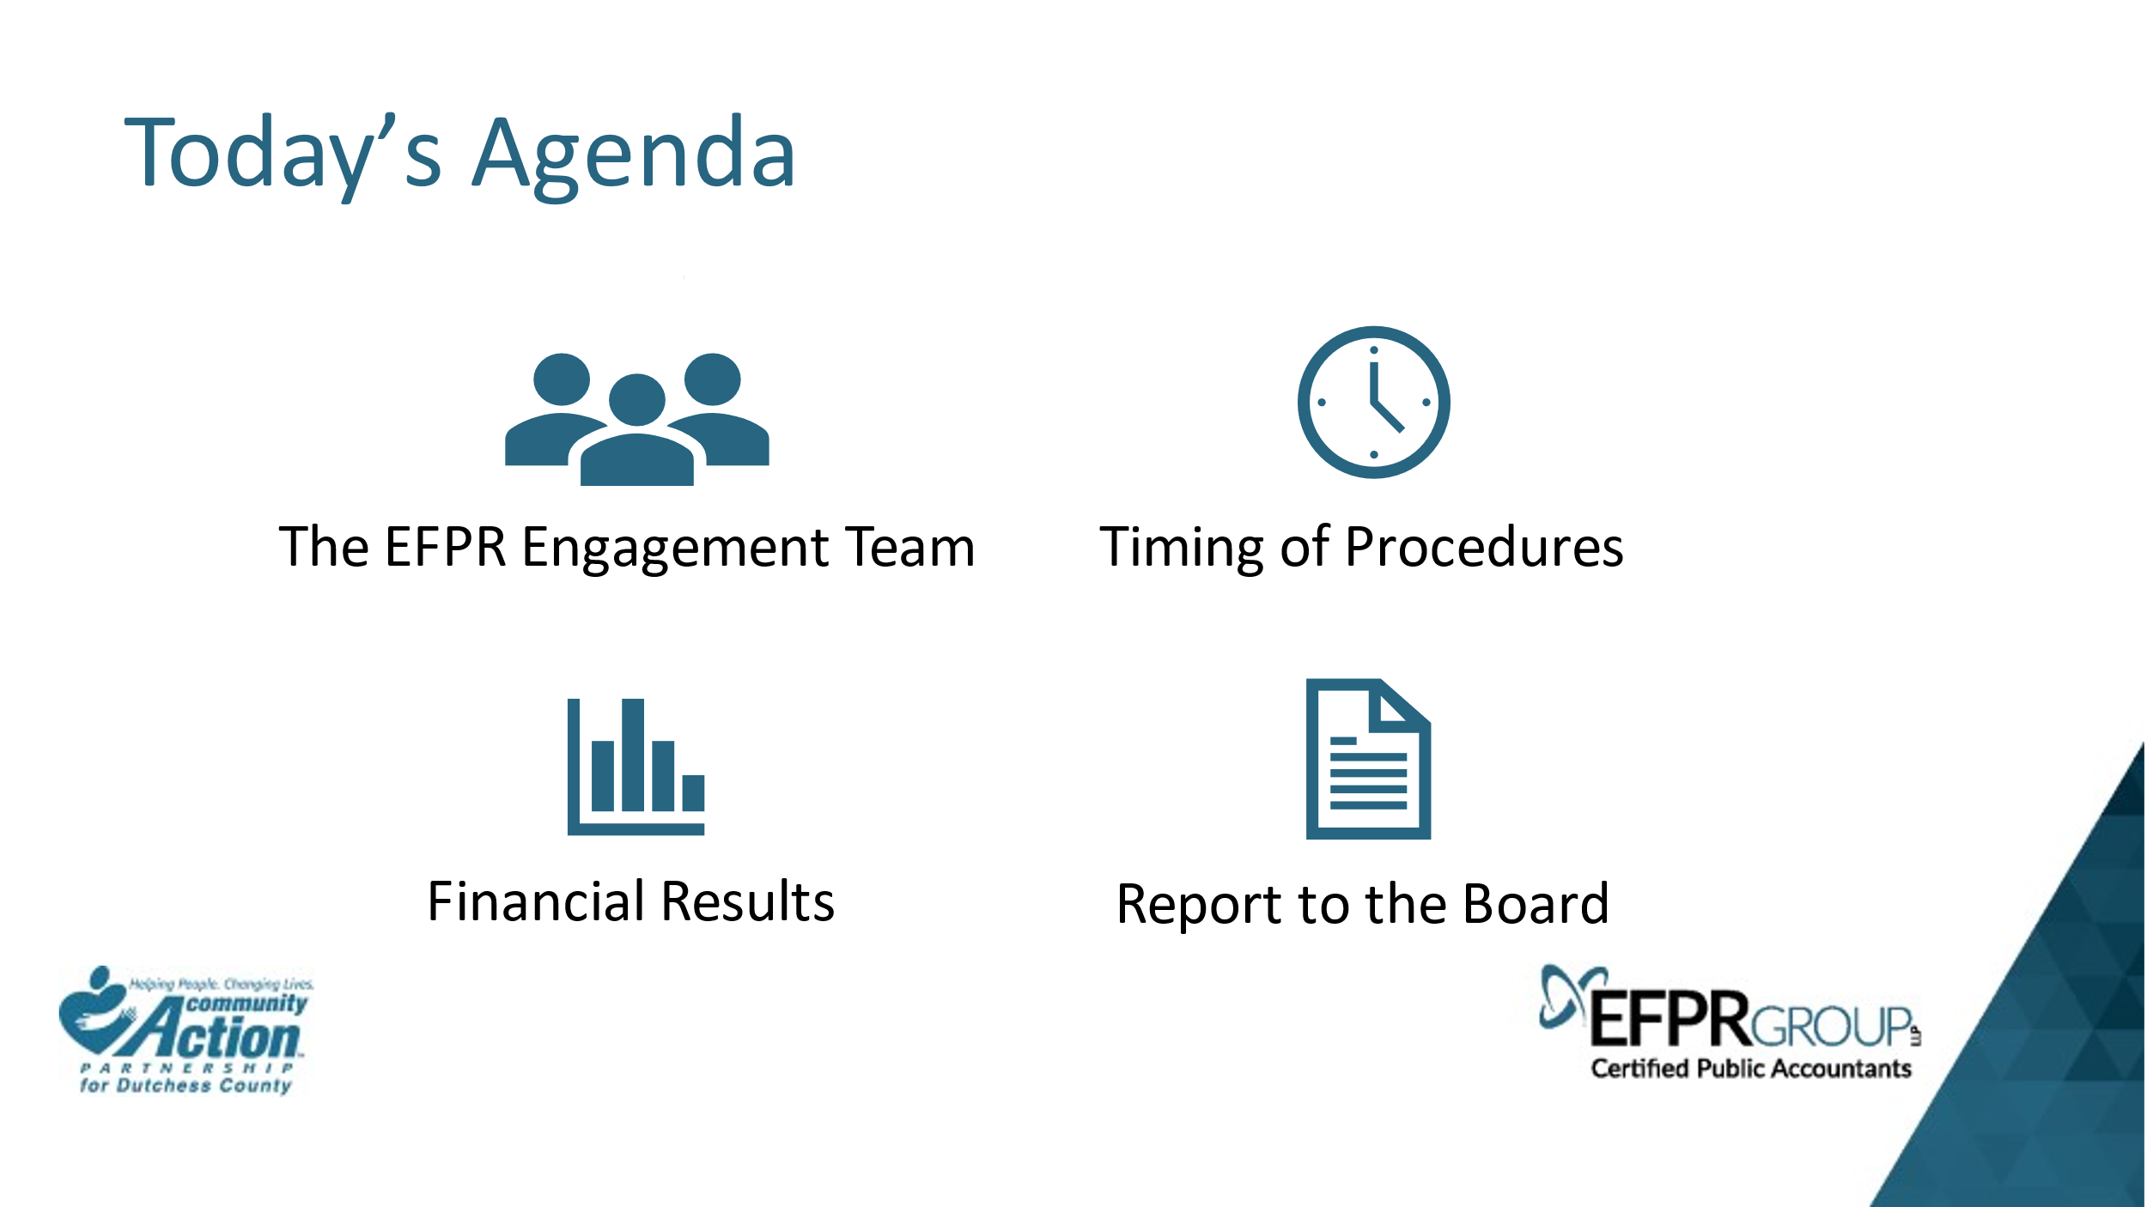

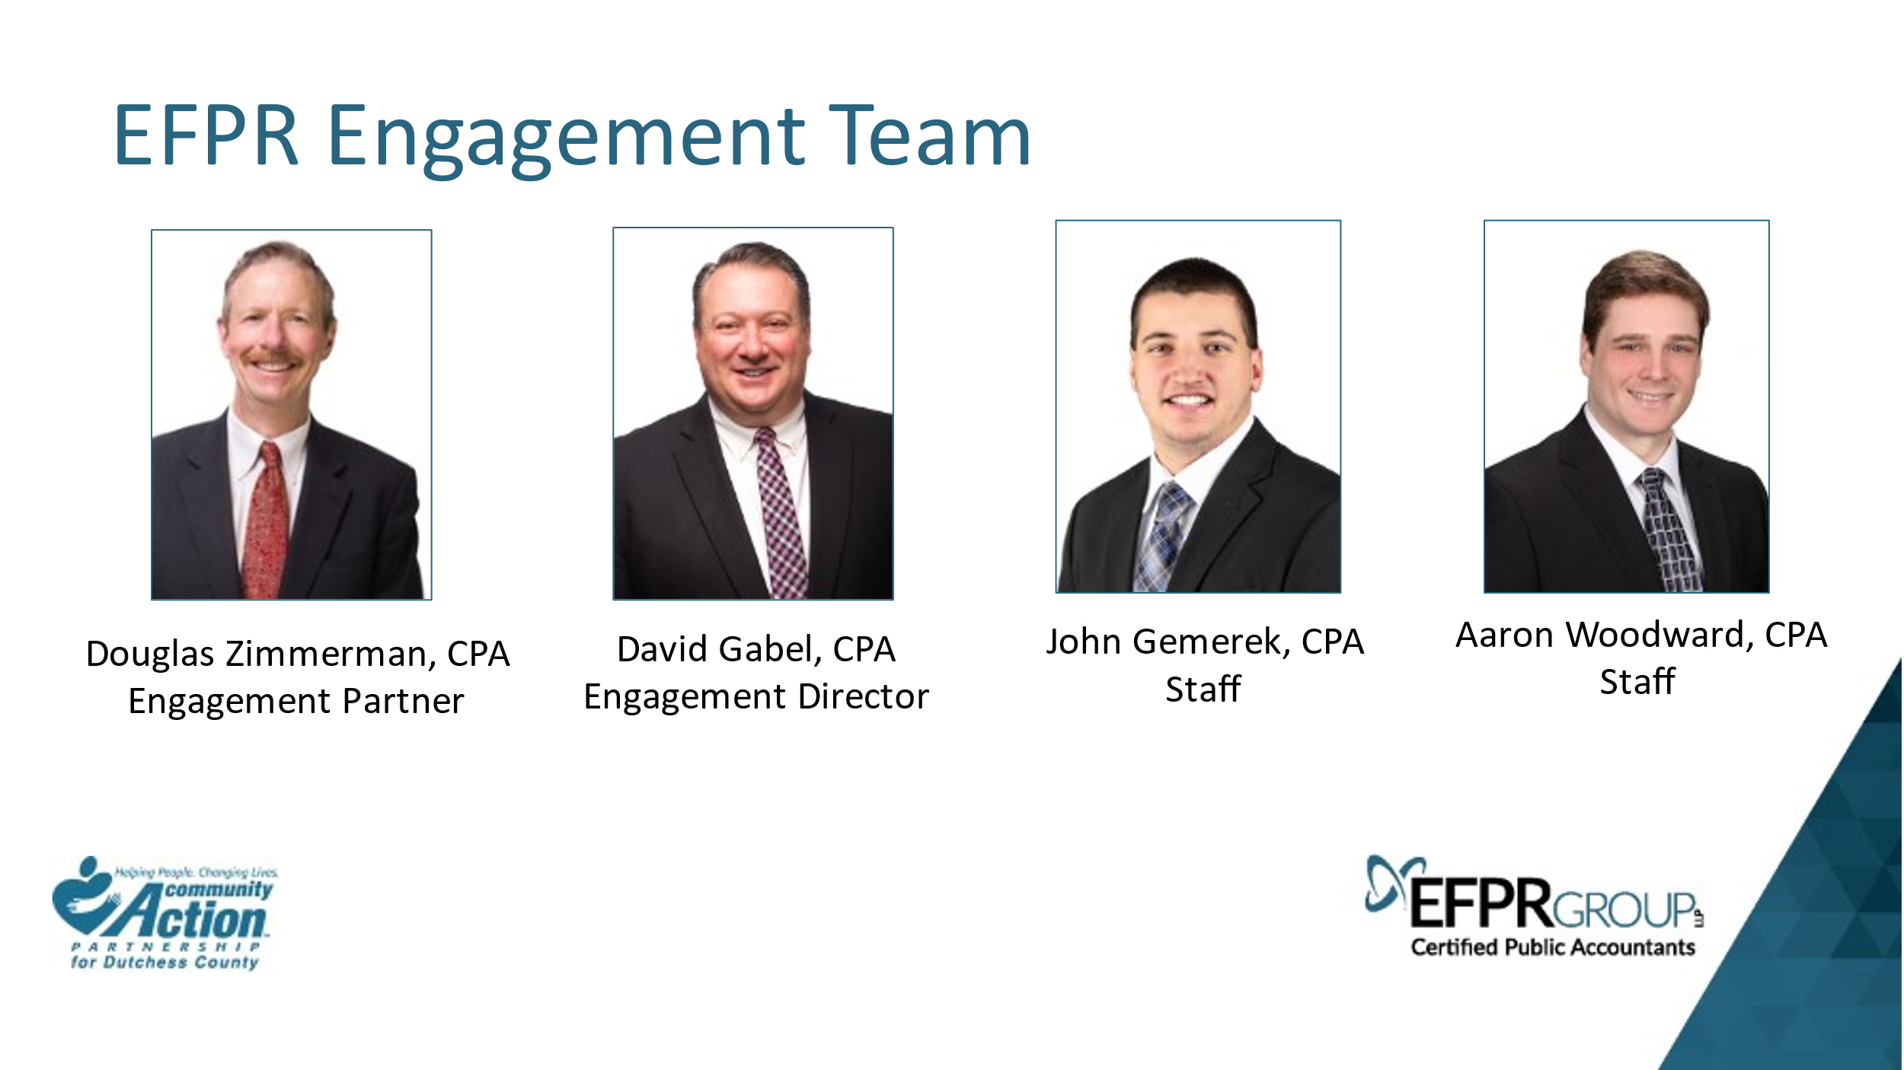

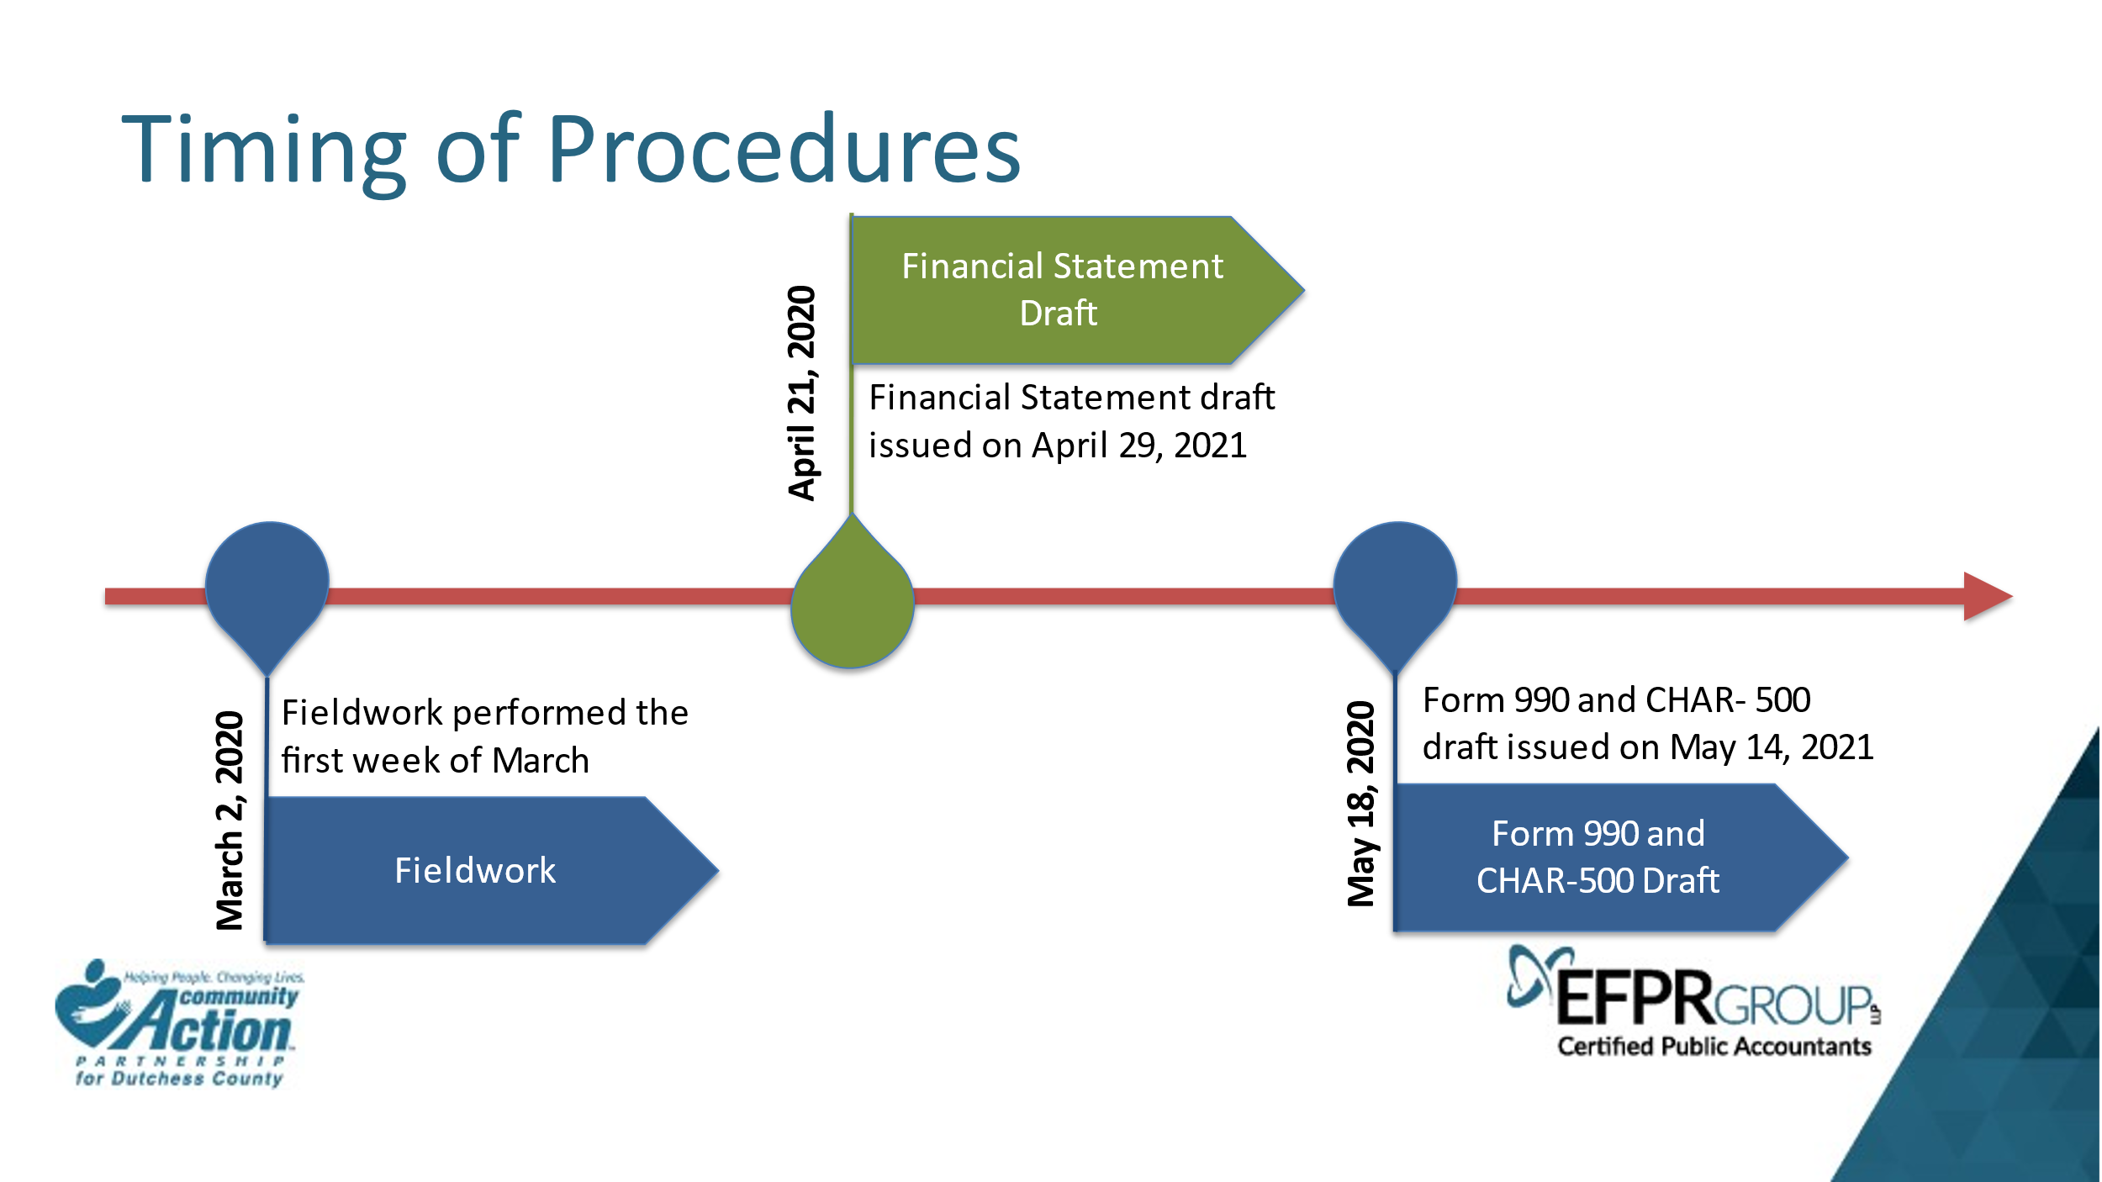

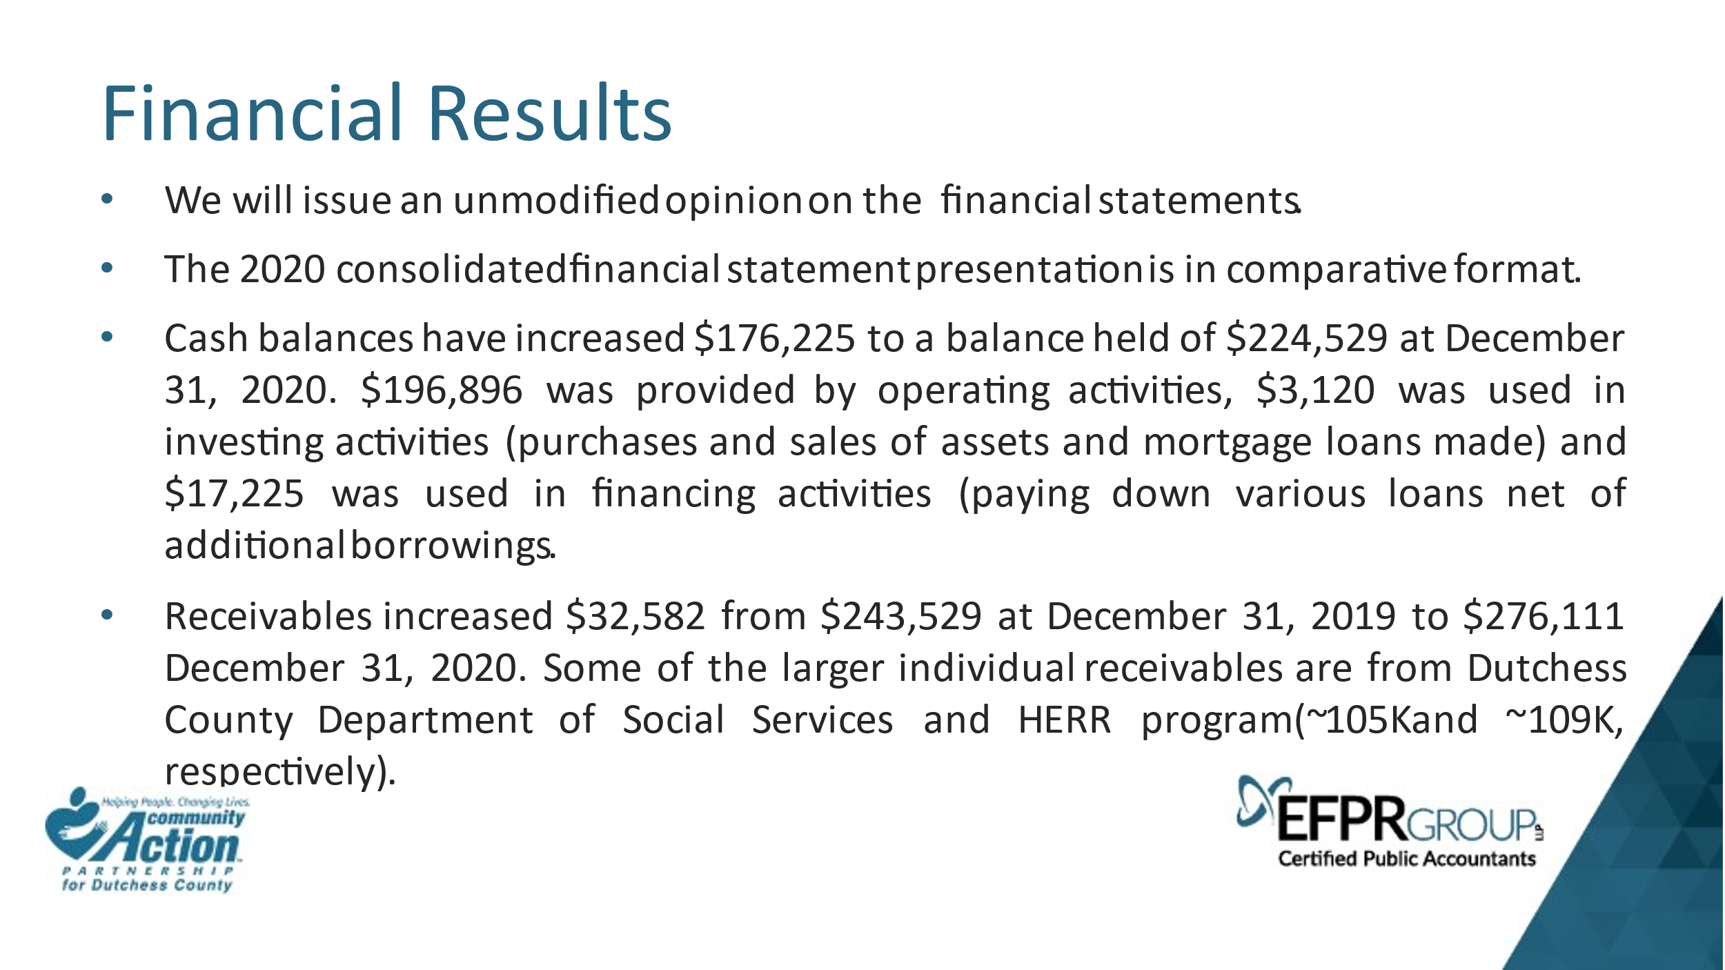

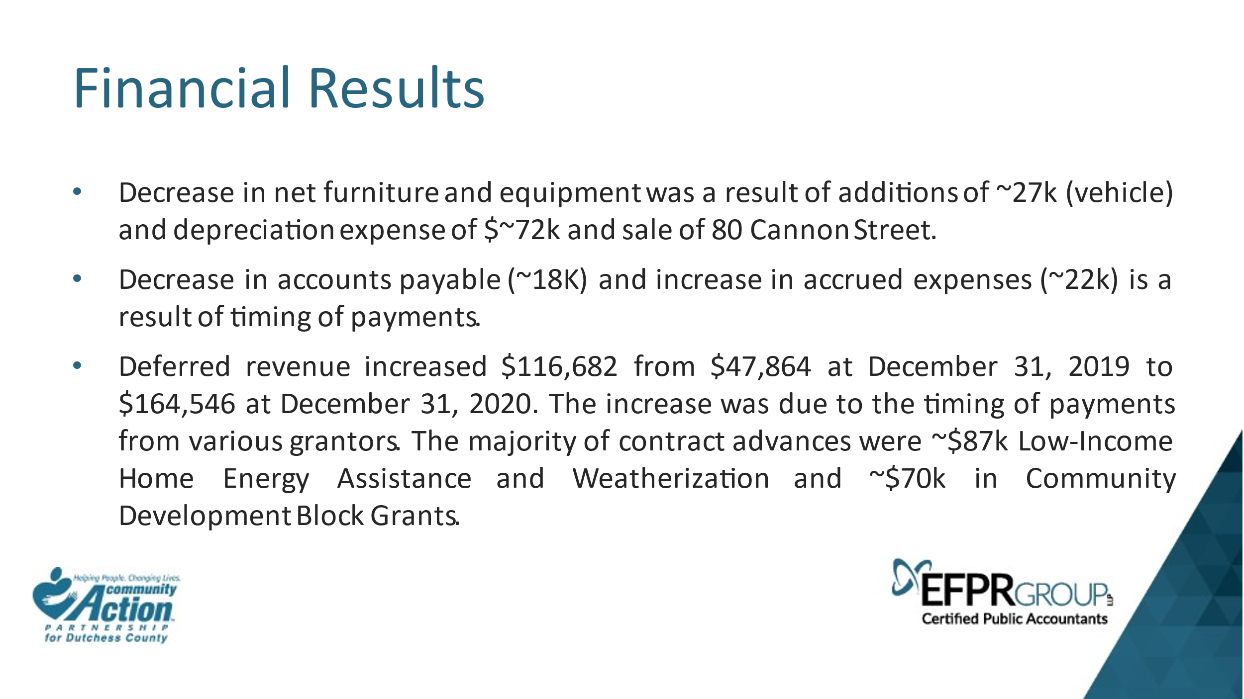

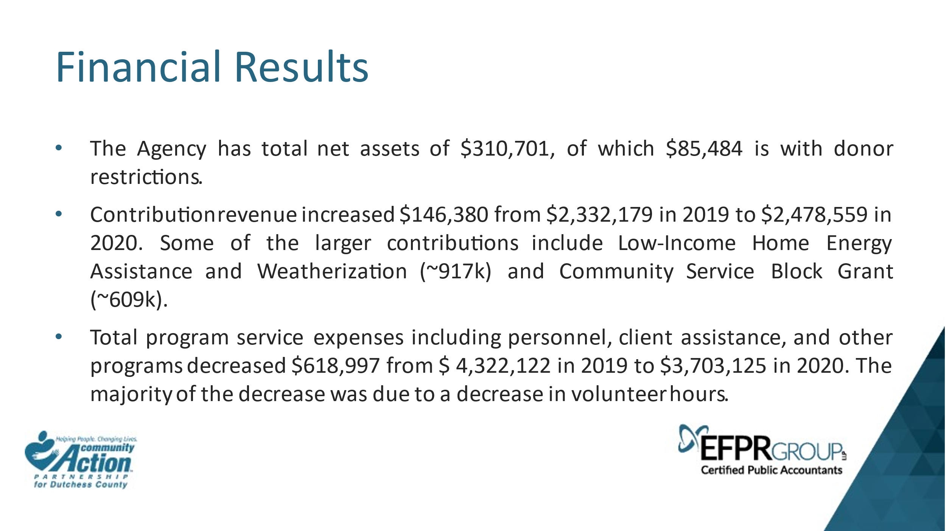

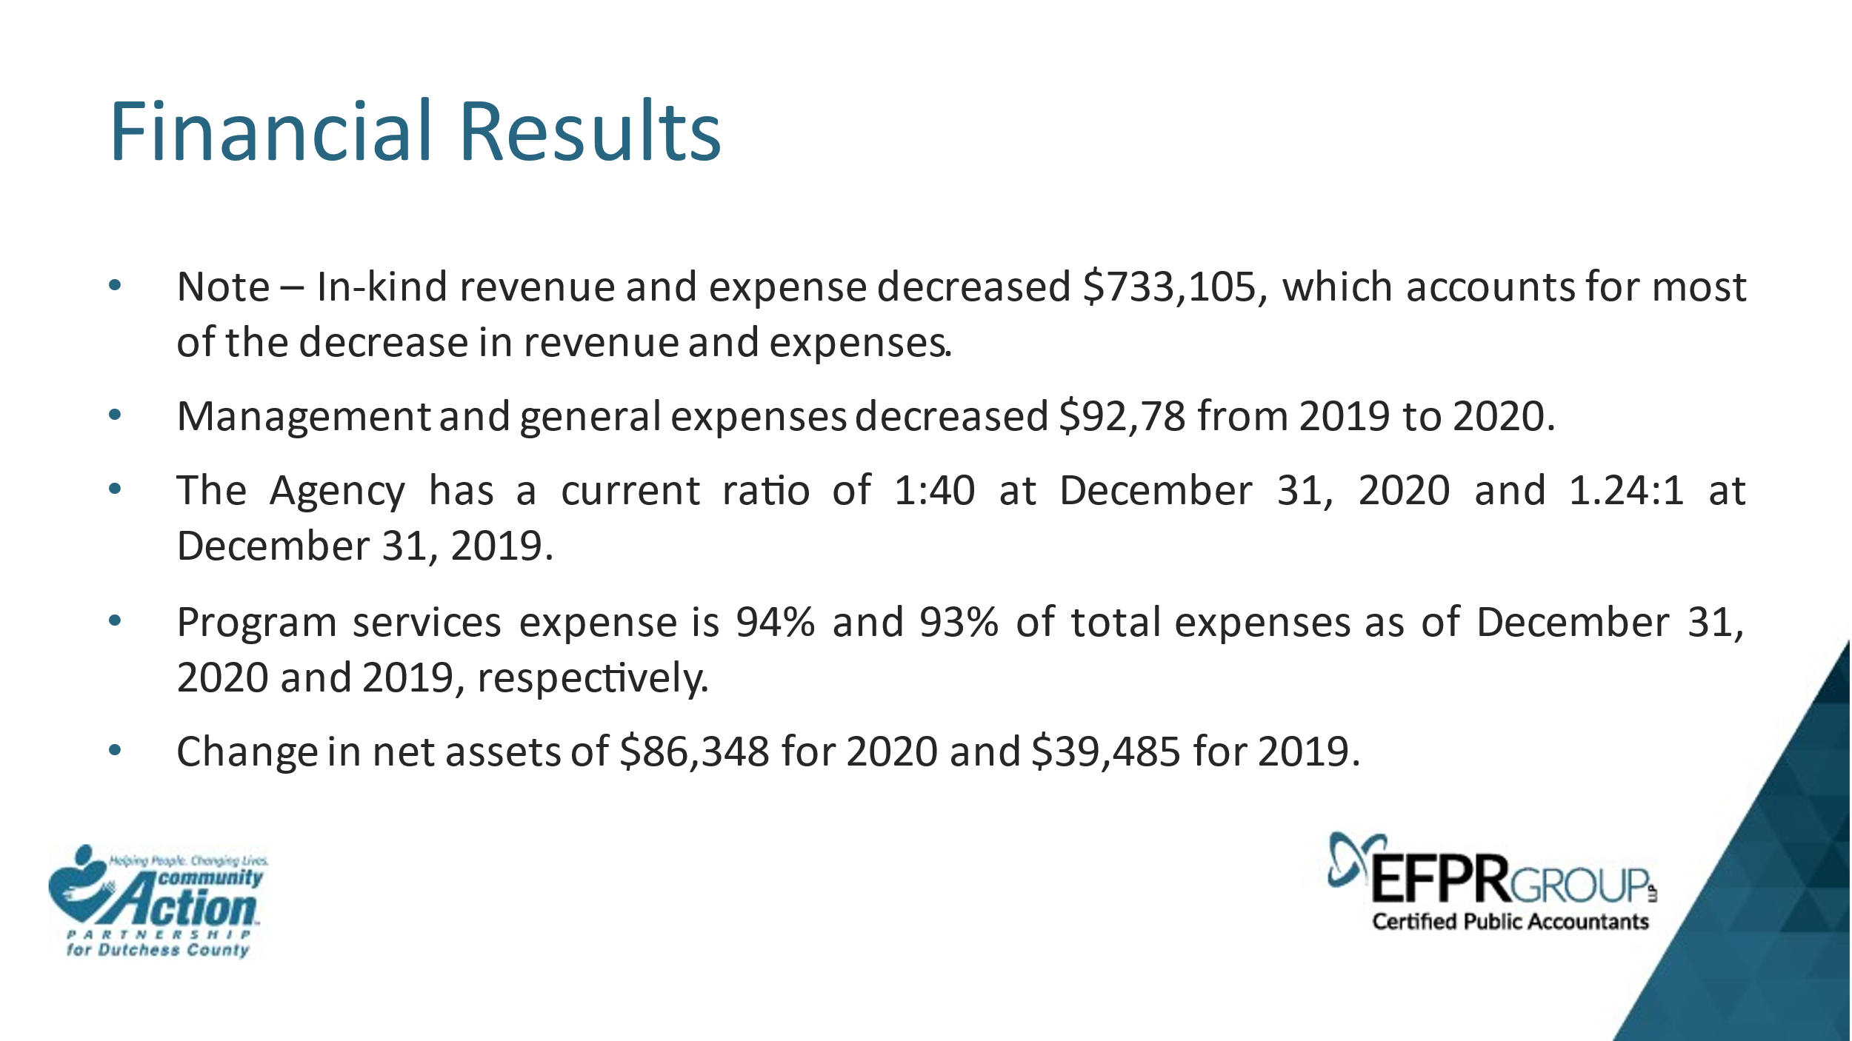

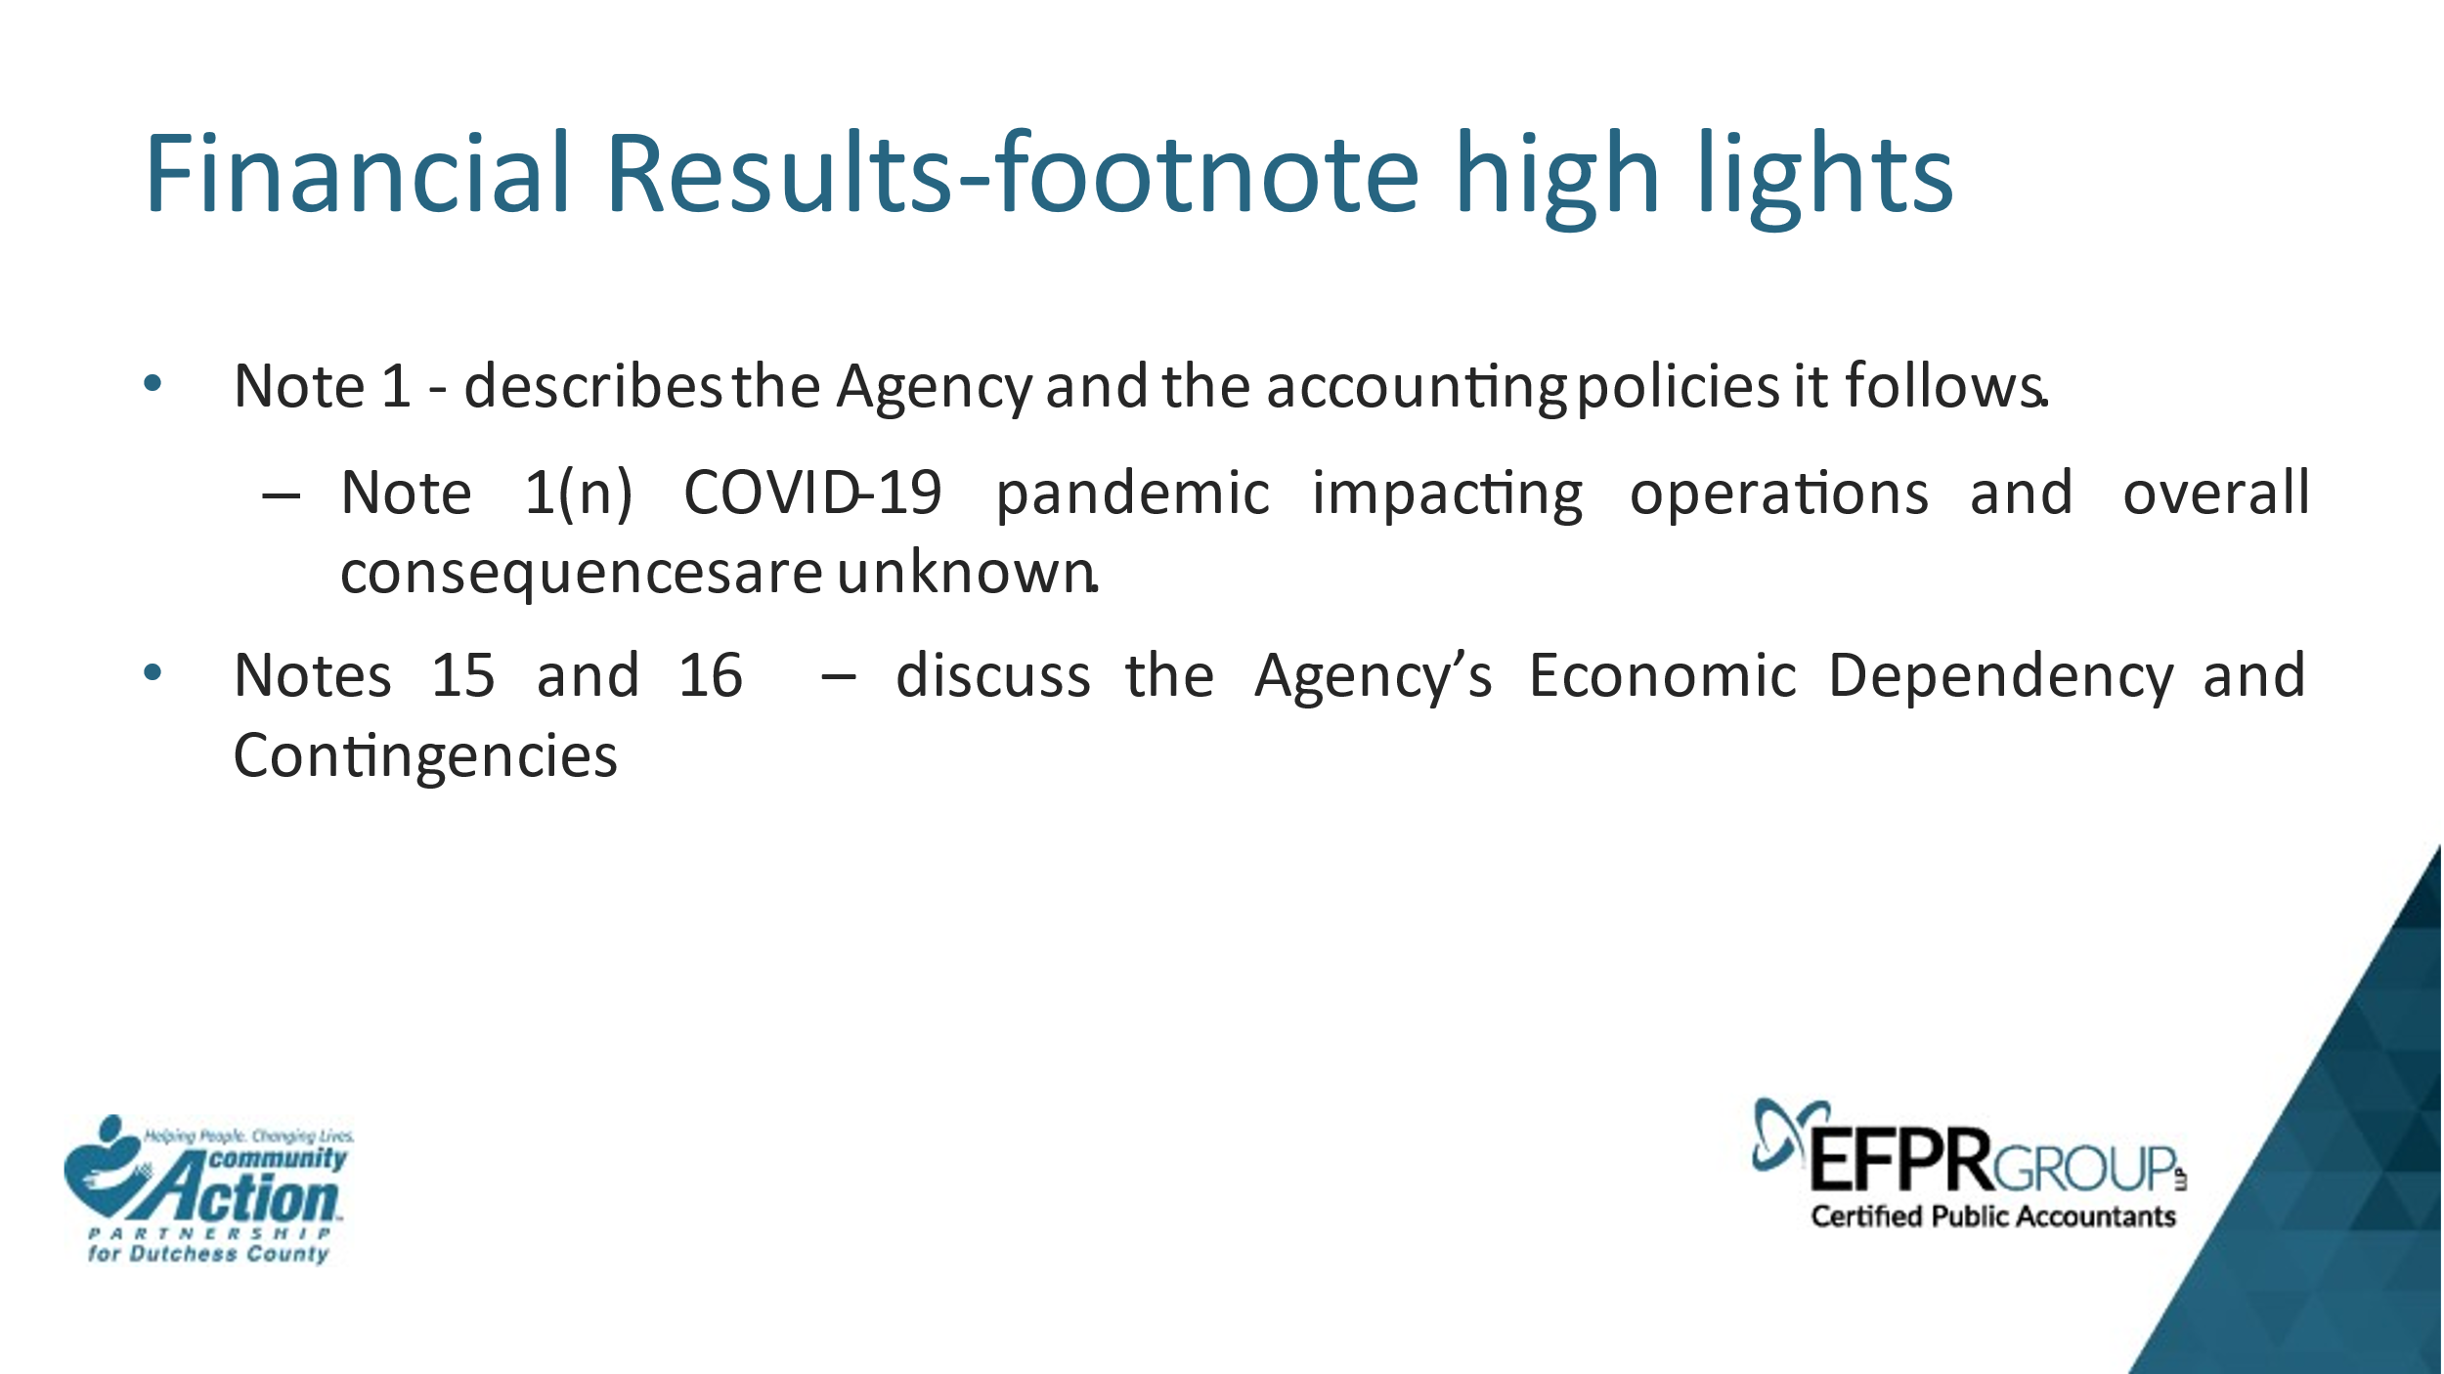

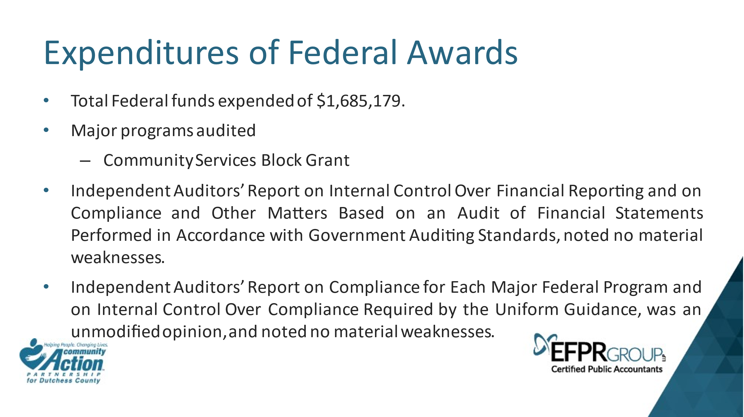

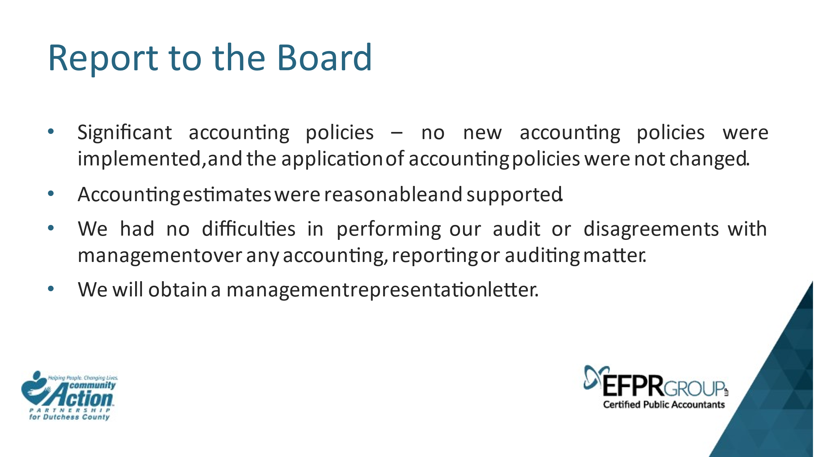

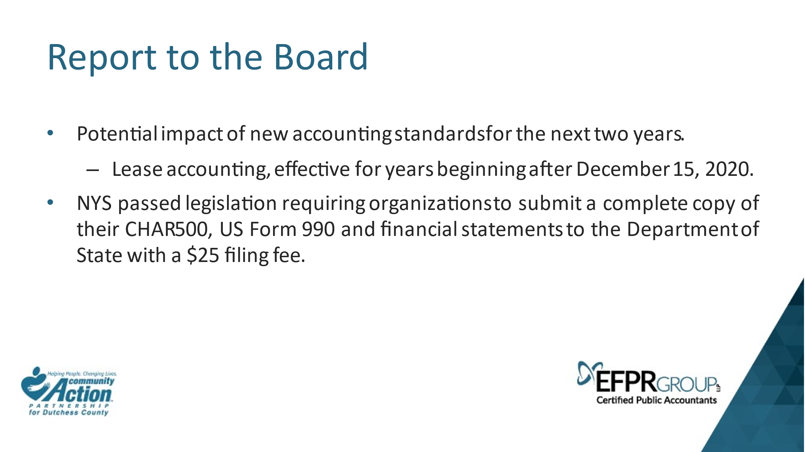

Motion to accept the Audit Report by David Gabel, EFPR Group. Peter Idema made the motion to accept the Audit Report. Charlene Smart seconded the motion. All were in favor and the motion carried.

Executive Session: Jill Harlow, Administrative Assistant, is asked to drop out of meeting at 4:15pm and to pause recording.

Executive Session Ended: Jill Harlow, Administrative Assistant, is asked to return to meeting and resume recording at 4:25pm.

Old Business: Elizabeth C. Spira, CEO, stated that the Department of State measures us through our TRACS and ACROS. They measure us on whether the board members have been apprised of their rolls and responsibilities. We attempted to register all the board members with the training on the NYSCA site in the past but had issues. Jackie from NYSCA revised the training for board members so that we could fit it in a board meeting. We will try to set this up for the September meeting as June’s meeting is packed and July and August we do not meet.

New Business: Kathleen Vacca, the low-income representative on our board, has accepted a job with Senator Serino’s office which will start June 1st, 2021. The details of Kathleen’s new position will be brought up to the board when she knows more. Kathleen’s seat on the board will be looked into as to whether it conflicts with the new position.

Motion to adjourn meeting: Peter Idema made the motion to adjourn the meeting at 4:28 pm. Charlene Smart seconded the motion. All were in favor and the motion carried.

Next Meeting:
Date: June 17, 2021
Location: Zoom Meeting

