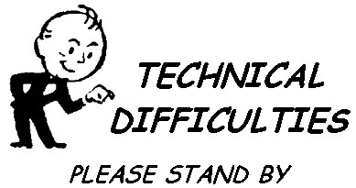

Sorry! We are experiencing technical difficulties with our Donation link right now.

We apologize for the inconvenience, and appreciate your understanding.
We are working hard to try and resolve the issue as soon as possible.
Thank you for considering Community Action for your donation. Until this issue is resolved, please send by mail to:

Community Action Partnership for Dutchess County
Attn: Accounting Department
77 Cannon St.
Poughkeepsie, NY 12601

If you would like to be notified as soon as the issue is resolved, please email Laurie Kelsey, Administrative Assistant, at lkelsey@dutchesscap.org

