# Board Roles & Responsibilities:

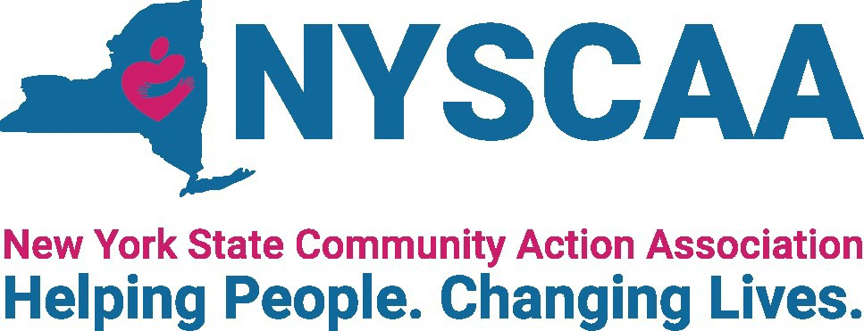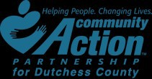

**Nonprofit Community Action Agencies**

## 10/21/2021

**PRESENTED BY:**

**Jacqueline Orr New York State Community Action Association**

**(NYSCAA)**

**2**

* Legal Requirements Governing Tripartite Boards
* A Few Points About How a Board of Directors Operates
* Role of the Tripartite Board
* Key Responsibilities of the Tripartite Board

**Agenda**

**3**

**Legal Requirements Governing Tripartite Boards**

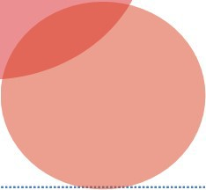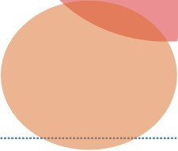

**4**

**Federal CSBG**

**Act, block grant regulation, guidance**

**State CSBG**

**statute, regulations, policies**

**IRS tax-**

**exempt org. requirements**

**CAA Boards**

**CSBG grant**

**agreement/ contract with state**

**Articles of**

**incorporation**

& **bylaws**

**State**

**Nonprofit Corporation Act**

**Other**

**federal/state funding requirements**

**Legal Requirements**



**5**

**42 U.S.C. § 9910**

**True or False**

* **Requires tripartite board to be fully engaged in the development, planning, implementation and evaluation.**
* **The tripartite board composition is a suggested practice and not required by the federal CSBG Act.**

**Remainder**

**individual or group from private sector**

**At least 1/3**

**low-income representative**

**1/3 elected or**

**appointed public officials**

**Federal CSBG Act**

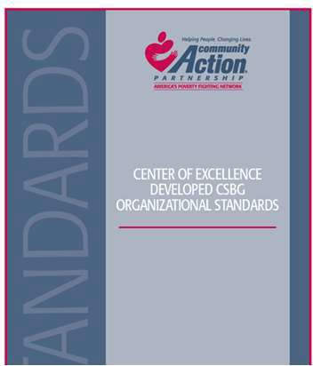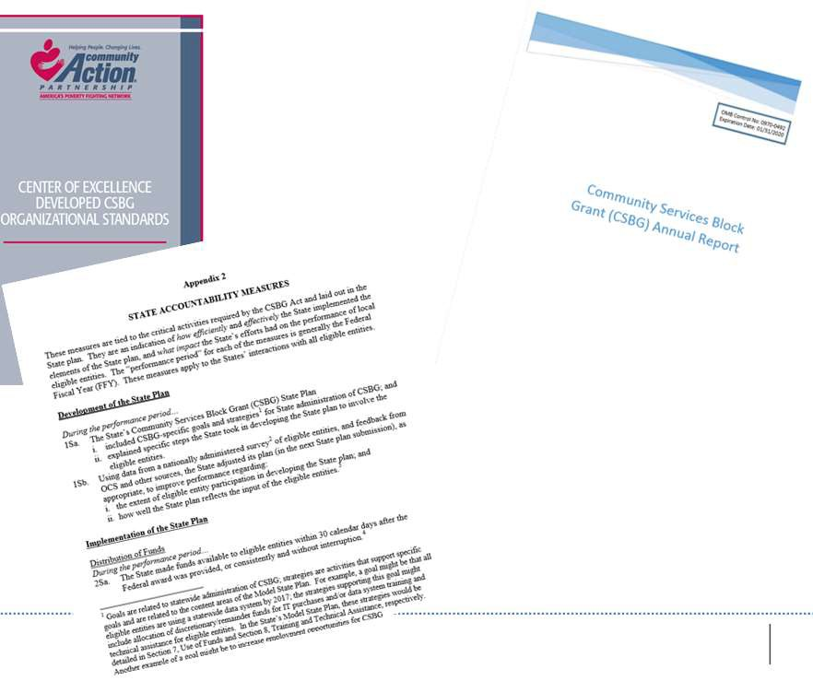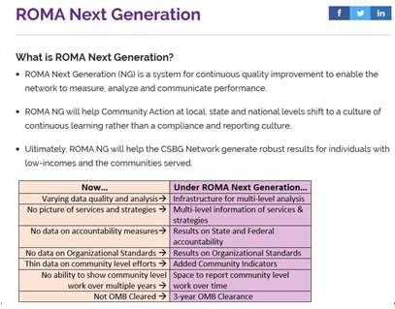

**PERFORMANCE MANAGEMENT**



**7**

**The Big Picture:**

**A Few Points About How a Board of Directors Operates**

# Operation Framework

**8**

**Board of Directors**

## The board acts only as a body

– Opportunity for group discussion and deliberation is important

## Sole employee of the board is the executive director

#### Executive Director

**Staff Staff**

# Board Member/ Staff Contact

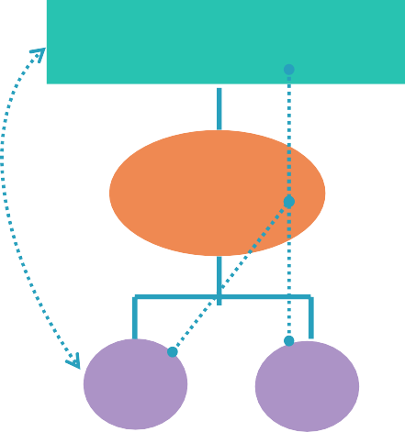

**9**

**EXAMPLES**

## Board of Directors

**Direct Contact Via the ED**

1. **Seek staff input**

on ED evaluation

1. **Reports of fraud, misuse of resources, discrimination or harassment involving the ED**

#### Executive Director

**Staff Staff**

1. **Coordinate board meeting logistics with staff admin**
2. **Staff liaison assists with board committee business**

# Board Operational Guide



**10**

### Bylaws serve as an organization’s operational guide

***Bylaws***

***Article I***

*Thou shall read the bylaws****.***

### See bylaws for information about:

* + Board member composition
  + Meeting frequency, notice
  + Officers
  + Committees
  + Votes, quorum
  + **And more. . . .**

**11**

**Board Committees**

* **Committee work is essential to smooth and efficient operation of board and CAA**
  + Executive directors are not committee members
* **Most state laws permit board members to rely on information provided by committees**
  + But board members must have a reasonable basis for believing that the committee is a competent source of information
* **Regular review of committee structure is recommended**



**12**

**Role of Tripartite Board**



**13**

**Fiduciary Duties**

**NONPROFIT BOARD MEMBERS**

* **Duty of Care – Diligent**
  + Acting with the care of a prudent person in similar circumstances
  + Attend and be prepared at committee and board meetings
  + Asking hard questions
  + Reading materials
  + Deliberating the decision

**14**

* **Duty of Loyalty – Faithful to CAA**
  + Act in good faith and in the best interests of CAA
  + Put the interests of the organization before personal and professional interests
  + Disclose and avoid conflicts of interest

**Fiduciary Duties**

**NONPROFIT BOARD MEMBERS**

**15**

**Key Responsibilities of the Tripartite Board**

**Key Board Responsibilities**

**16**

**Accountability**

**Performance**

**Generating Funds**

**Engagement**

**Planning**

**Mission**

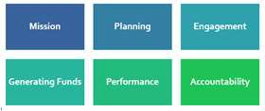

**Key Board Responsibility**

**17**

**Mission**

**18**

* **Why mission matters:**
  + Provide clarity of purpose to stakeholders
  + Guide major decisions
  + Prevent “mission creep”

**Why Mission Matters**

**Review Update**

**Use**

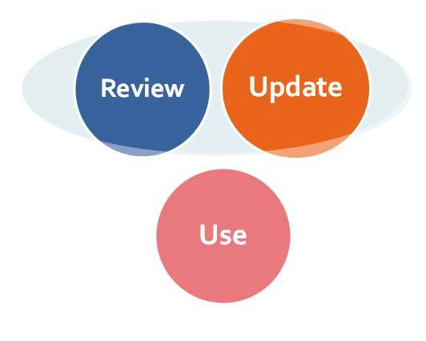

**19**

**Mission**

**Board Role and Mission**

**20**

* **Ways boards highlight and use the mission:**
  + Recite at board meetings
  + Reference in meeting agenda
  + Include on business cards
  + Discuss in relation to all board actions

**Use Mission**

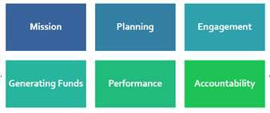

**Key Board Responsibility**

**21**

**Planning**



**22**

**Strategic Plan**

**5-Year Review**

**(Organization-wide)**

**Community**

**Action Plan**

**1-Year Review**

**(Community needs assessment/CSBG- specific- 3 years**

**Planning Under CSBG**

**23**

* **Approaches to help a board meet its planning and strategy development obligations:**
  + Form a planning/strategy committee
  + Uses the strategic plan to frame board discussions
  + Use a strategic agenda

**Engage in Planning**

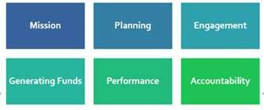

**Key Board Responsibility**

**24**

**Engagement**

**25**

**With**

**Stakeholders/ Community**

**Engagement**

**With Board/**

**Organization**

**Internal and External Responsibilities**



**26**

**Regularly**

**Orienting & Training**

**Strategically Recruiting**

**Building**

**Relationships**

**Connecting with**

**Conducting Community Assessments**

**Ways to INCREASE Engagement**



**27**

**Follow selection procedures**

**Require applications**

**Recruit smartly & strategically (What is our**

**primary purpose and what do we need to accomplish?)**

**Board Selection Procedure -**

**Strategically Recruiting**

**Use board committee**

**28**

**…leads to board engagement which ensures strong retention**

**Onboarding-**

**Orientation and Training**

* **Use a governance committee to work with executive director and designated staff to:**
  + Develop a comprehensive approach
  + Identify topics, e.g., financial oversight, board operations, etc.
  + Establish methods: e.g., webinars, in-person, etc.

**29**

**Building Relationships**

**Board Members/Executive Director**

* **Meet one-on-one with board members**
* **Periodic check-ins**
* **Provide board members with opportunities to develop their skills as board members**
* **Help board members get to know each other**
* **Encourage board members to be actively engaged at board meetings**

**30**

**Board Assessment**

**Process**

1. **Get your full board on board!**
2. **Establish a group of board members to oversee the process**
3. **Administer the assessment tool**
4. **Tabulate responses**
5. **Discuss results – strengths, weaknesses**
6. **Establish a realistic action plan**
7. **Follow up and reassess!**

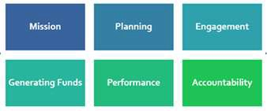

**Key Board Responsibility**

**31**

**Generating Funds**



**32**

**\*Executive director and staff**

Capital campaigns

**\*Board and executive director**

Preparing bid proposals

Putting on special events

Writing grants

Soliciting gifts

**Proposals\***

**Fundraising\***

**Two Main Ways CAAs Generate**

**Funds**

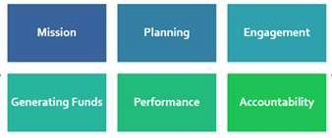

**Key Board Responsibility**

**33**

**Strategic & Programmatic Performance**

**Board’s Role in Programmatic & Strategic Performance**

* **Establishing a culture of using data to make decisions**

**34**

**Performance management**

**Cost effectiveness?**

**Quality?**

**Outcomes?**

**How can we improve our . .**

**Board’s Role in Programmatic & Strategic Performance**

* **Inquiring about relevancy of data received and the metrics used**

**35**

**Performance measurement**

**What data will need to be captured**

**What metrics matter?**

**How will we know if we are meeting community needs prioritized?**

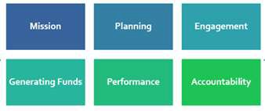

**Key Board Responsibility**

**36**

**Accountability**

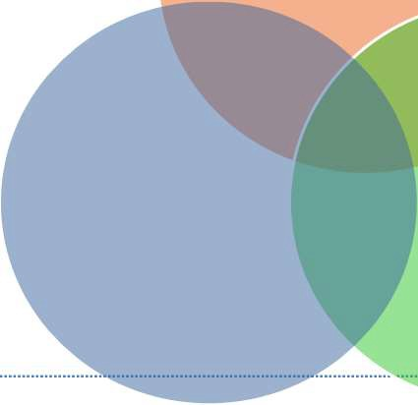

**37**

**OPERATIONAL**

**LEGAL**

**FINANCIAL**

**Ensure Accountability**



**38**

* Select and monitor auditor

4

* Set and reassess CEO compensation

3

* Approve and monitor annual budget

2

* Review financial statements

1

**Oversee Financial Standing**

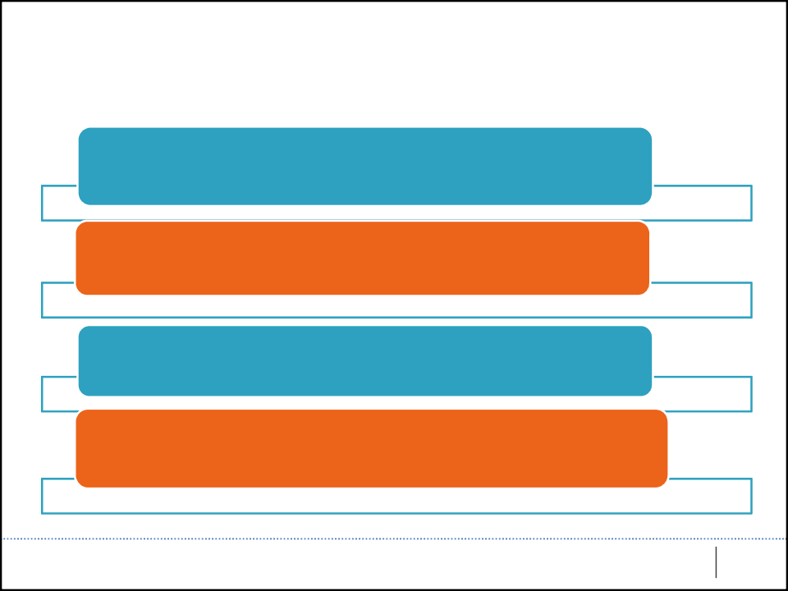

**39**

The organization has written **personnel policies** that have been

reviewed by an attorney and approved by the governing board within the past 5 years.

The **fiscal policies** have been reviewed by staff within the past 2 years, updated as necessary, with changes approved by the governing board.

The organization has a **whistleblower policy** that has

been approved by the governing board.

Each board member has signed a **conflict of interest**

**policy** within the past 2 years.

**Policies - Operational**



**Common Board Missteps**

**Board members acting as individuals**

**Micromanagement**

**40**

**Too much deference to executive director**

**Not discussing critical issues**



**41**