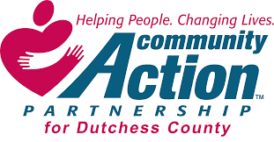

Community Action Partnership for Dutchess County, Inc.
2021 Annual Report

Administrative Offices:
77 Cannon Street Poughkeepsie, NY USA 12601 Phone: 845.452.5104 x103 Fax: 845.625.1510
Email: espira@dutchesscap.org

Board of Directors:
Charlene Smart, President Josh Stratton, Vice President Pete Idema, Treasurer
Dr. David Scott, Secretary John Penney
Paul Daubman Sr. Kathleen Vacca

Our Mission...
To partner with individuals and families to eliminate poverty and identify the resources and opportunities available to them to enhance their self-reliance.
“Engaging Communities, Empowering Individuals”

Total Income $3,134,397
Expenses

8%

92%

Total Expenses $2,809,199

- Program $2,868,803 (92%)

- Admin/Fundraising $265,594 (8%)

Net Assets $325,198

